Open Grid Forum
Reference Model Materials, 26th Mar 2007

Introduction
This document is a working document describing the top layers of the class diagram for Grid Components.

Grid Component 1

General
As per the EGA Reference Model v1.5, the Grid Component is the super class of all managed entities within a Grid. The highest level of Grid Component interfaces, relationships and sub-classes is shown in below.

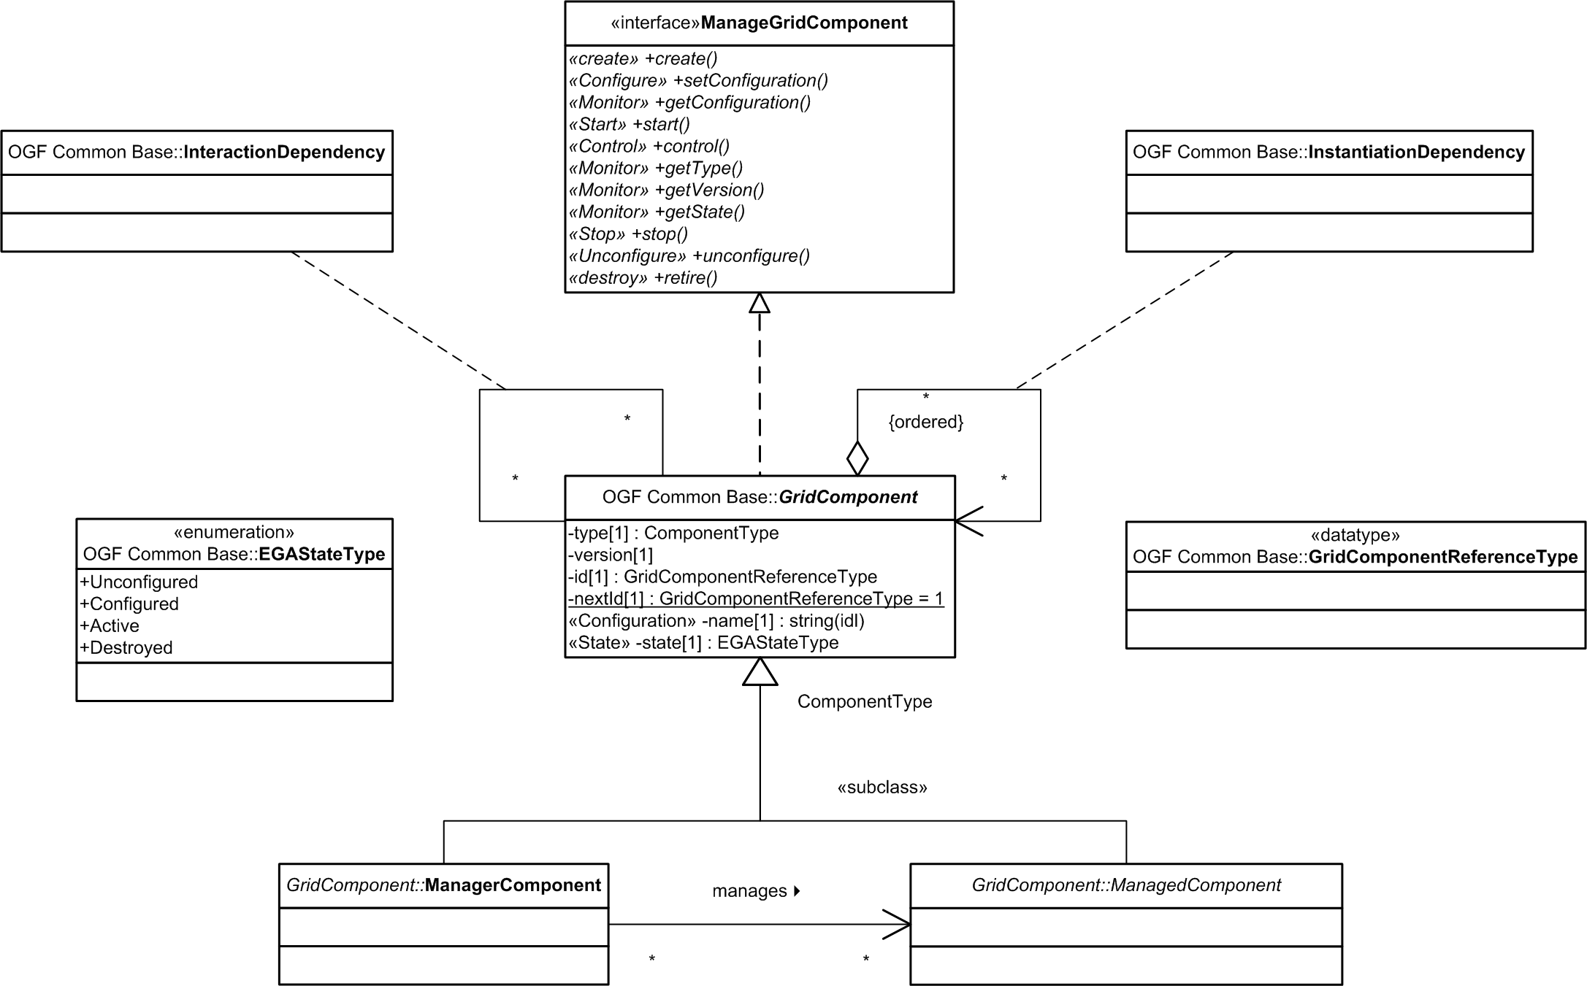

Figure i - The Grid Component

Whilst the some of the attributes and operations have been defined, these are less interesting at present than defining the sub-classes and relationships.

The GridComponent Class
Everything that is managed within a Grid is a Grid Component and is represented by the GridComponent class. This is an abstract class and has the following base set of attributes and operations.

Attribute StereoTypes
Using a stereotype may not be the appropriate mechanism, but the intent is to divide attributes into those that must be configured in order for a Grid Component to be started and those that essentially define its state.
- Configuration – Any attribute that may be considered a configuration parameter, i.e. an attribute that is required to be configured or set before the GridComponent can be started. These are not necessarily immutable, i.e. they may be changed during any part of the life-cycle of the component.
- State – Any attribute that may be considered to describe part of the run-time state of the GridComponent, which is not a Configuration parameter. Attributes that define state could be a simple state attribute, or they could be volatile attributes of the GridComponent, for example instantaneous or averaged performance metrics.

Attributes
- type (ComponentType) – the type of the GridComponent, for example Computer, Network Switch, Operating System, Server, DatabaseServer etc. This may be an implementation specific detail and may be removed.
- version – the version of the component.
- id – a unique identifier for the instance of the GridComponent. Ideally for any given system, such an id must be unique for the life time of that system, so as to aid diagnosis and historical event correlation.
- nextId – the next, unallocated unique identifier. This is a class attribute. Again an implementation detail that may be removed.
- name – a configuration attribute that is just a convenient, preferably easy to remember name for the Grid Component.
- state – the exposed state of the Grid Component, a state stereotype attribute. This maps to the set of defined states in the State Machine diagram for the Grid Component. Clearly sub-classes of Grid Component may well have internally realized, and perhaps externally visible sub-states and additional transitions, or sub-transitions if you will.

Operations
These are exposed through the ManageGridComponent interface, see below.

The ManageGridComponent Interface
The operations for the GridComponent class are exposed through the ManageGridComponent interface.

Operation StereoTypes
Again StereoTypes may not be the best mechanism, but the intent is to map actual verbs to the set of stereotypical verbs identified in the Grid Component state machine, i.e.
- Create(/Discover)
- Configure
- Start
- Monitor
- Control
- Stop
- Unconfigure
- Destroy

Operations
The following a non-exhaustive list of potential operations.
- create() –
- setConfiguration() –
- getConfiguration() –
- start() –
- control() –
- getType() –
- getVersion() –
- getState -
- stop() –
- unconfigure() –
- retire() -

Associations
At the highest level there are two types of relationships or associations allowed between Grid Components –
- Interaction Dependencies
- Instantiation Dependencies

The InteractionDependency Association Class
Interaction Dependencies are dependencies where one Grid Component interacts directly with another in a peer relationship. Examples of this dependency include connections and message passing relationships such as –
- Server A is connected to Ethernet Switch B..
- Service C exchanges SOAP message D with service E.
- Management service F manages Operating System G.
These will be modeled as sub-classes of the InterationDependency association class.

The InstantiationDependency Association Class
Instantiation Dependencies are dependencies where one Grid Component depends on another in order for it to exist or for it to be instantiated. Examples of this dependency include hosting and compositional relationships such as –
- Operation System A is hosted on Computer B.
- Service C is comprised of sub-services D and E.
These are essentially hierarchical relationships and will be modeled as sub-classes of the InstantiationDependency association class.
NOTE - It is unclear whether these should be ordered. Thus if A depends and B and C, and B must be started before C can be started, then B should also have a dependency relationship with C.

The ManagerComponent Class
An abstract sub-class of the GridComponent class, the ManagerComponent class represents Grid Components that manage other Grid Components. As per the Reference Model v1.5, for each logical Grid Component, there is a logical Grid Management Entity grid component that is responsible for managing the life cycle of that grid component. The ManagerComponent is not equivalent to a conceptual GME Component. Rather it captures the implemented management system. A ManagedComponent may be managed by multiple ManagerComponents, for example one could apply the provision verb, and one could apply the stop verb and so forth. A ManagerComponent could also manage multiple ManagedComponents, for example it could implement the provision verb for a wide variety of Grid Component types and instances.

The ManagedComponent Class
An abstract sub-class of the GridComponent class representing normal Grid Components, i.e. those that are not ManagerComponents.

Grid Component 2
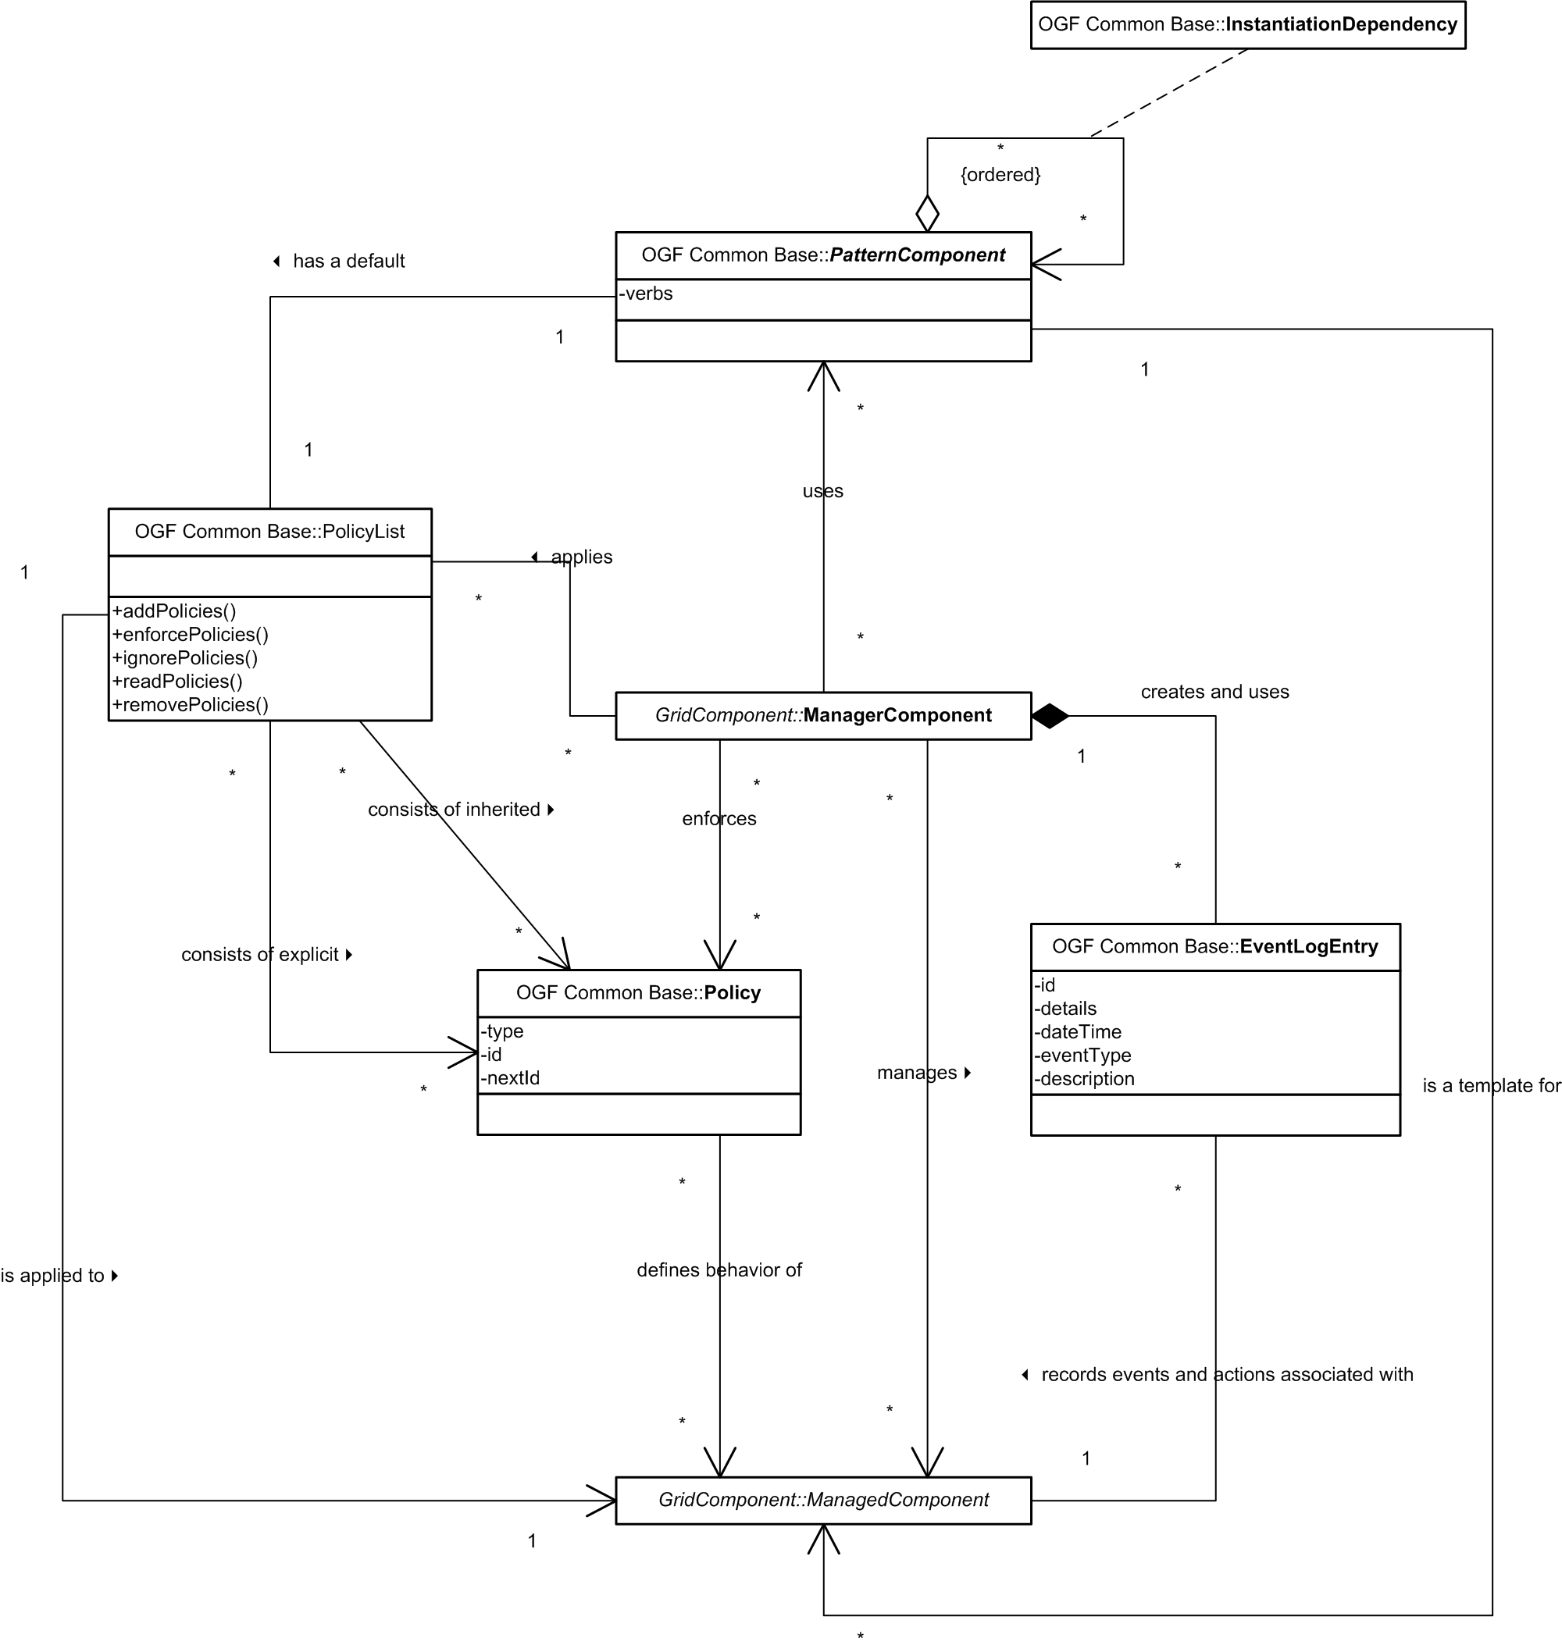

Figure ii – Pattern Components, Manager and Managed Grid Components

General
The relationships between the various direct descendents of the GridComponent class are described in above.

The PatternComponent Class
An abstract class, the PatternComponent describes the base/default configuration, dependencies, constraints, management functionality and policies required for a ManagerComponent to provision its associated managed Grid Component. PatternComponent instances effectively act as service descriptors for their associated ManagedComponent instances. The complete service descriptor for a service would be a DAG of PatternComponents that would define the default and potential set of DAGs, both of ManagerComponents and of ManagedComponents.

The ManagerComponent
Each ManagedComponent may be managed by a number of ManagerComponents. The ManagerComponent may be comprised of a set of sub-components, each responsible for a specific function of the ManagerComponent, including but not necessarily limited to –
- Policy
- Billing and accounting
- Orchestration
- Service Level Management
- Control
- Monitoring
It is unclear whether one should consider the “manages” association as a sub-class of the InteractionDependency association class or not.

Event log entries are maintained as a part of the ManagerComponent.

The ManagedComponent
The behavior of each ManagedComponent is defined by a set of policies. This set of policies is effectively maintained in a PolicyList within the ManagerComponent that enforces them. The policy list includes both explicit policies and inherited policies. Policies are not attributes of Grid Components, rather they are separately managed entities within the Grid, and may thus be referenced by many PolicyLists. Inherited policies are those that are explicitly associated with a GridComponent higher up the InstantiationDependency DAG so that they can be propagated to all components of a specific type below that GridComponent. For example a grid component A could have an instantiation dependency on 5 instances of grid component B. A policy that can only be applied to grid components of type B may be explicitly associated with A so that it will be applied to all instances of B that A depends upon. Explicit policies are directly associated with a given grid component and override conflicting inherited policies.

